MACHINE LEARNING CAPSTONE PROJECT

Predicting Adverse Event Seriousness: A Machine Learning Approach to FDA FAERS Data

Full Project Report
Data Source: FDA Adverse Event Reporting System (FAERS), 2025 Q1–Q4, with Out-of-Time Validation on 2026 Q1

Background
Adverse event seriousness in pharmacovigilance is formally determined through rule-based criteria (death, hospitalization, life-threatening, disability, congenital anomaly, or Important Medical Event). This determination depends on complete, structured case data that isn't always available the moment a case is received — creating delays in flagging cases for expedited regulatory submission, and occasional risk of miscoded or overlooked serious cases.
This project builds a machine learning model that predicts a FAERS case's likely seriousness using early-available structured features (drug, reporter type, demographics, reaction/drug counts) — before formal outcome coding is complete. The goal is early triage and quality control: prioritizing likely-Serious cases for faster review and flagging potential gaps in manual classification, not replacing the authoritative rule-based determination.
Objective & Problem Statement
Build a model that predicts whether a reported adverse drug event will be classified Serious or Non-Serious, to help prioritize review of incoming FAERS reports.
ICSR Processing Lifecycle
- Case Intake/Receipt
- Data Entry & Validity Check
- Case Triage / Seriousness Assessment ← model applies here
- Expectedness Assessment
- Causality Assessment
- Medical/QC Review
- Regulatory Reportability Determination
- Submission to Health Authority
Model role: early triage aid at Step 3 — flags likely-Serious cases for priority review before formal classification is complete; does not replace human/rule-based determination.
Scope
- Source: FDA FAERS Quarterly Data Extract, all 4 quarters of 2025 (Q1–Q4)
- Out-of-time validation: 2026 Q1, a genuinely unseen future quarter
- Problem type: binary classification (Serious vs. Non-Serious)
- Models evaluated: Logistic Regression, Random Forest, XGBoost, LightGBM

Data source
- Downloaded FDA Adverse Event Monitoring System (AEMS) Quarterly Data file from https://fis.fda.gov/extensions/FPD-QDE-FAERS/FPD-QDE-FAERS.html 4 files downloaded for year 2025.
- October - December 2025 posted on 27-Jan-2026 (Typo) ASCII (ZIP - 64MB) XML (ZIP - 106MB)
- July - September 2025 posted on 30-Oct-2025 ASCII (ZIP - 73.1MB) XML(ZIP - 115MB)
- April - June 2025 posted on 29-Jul-2025 ASCII (ZIP - 61.5MB) XML (ZIP - 107MB)
- January - March 2025 posted on 28-Apr-2025 ASCII (ZIP - 64.3MB) XML (ZIP - 111MB)

The FAERS ASCII Quarterly Data Extract 2025 consists of seven related tables, joined according to FDA's officially documented Entity Relationship Diagram (ERD):
Table | Contents | Join Key
DEMO | Patient demographics, one row per case | primaryid (base table)
DRUG | Drug/biologic info, role (PS/SS/C/I), 1+ rows per case | primaryid
REAC | MedDRA reaction terms, 1+ rows per case | primaryid
OUTC | Outcome codes — defines the target variable | primaryid
THER | Therapy start/end dates, per drug | primaryid + drug_seq
INDI | Indication for use, per drug | primaryid + drug_seq
RPSR | Report source (rare field) | primaryid
Load dataset (2025):
FAERS quarterly data is available in two formats — ASCII or XML — and for this project, the ASCII format is used, which uses a $ delimiter to separate fields.
Demo (Q1-Q4):
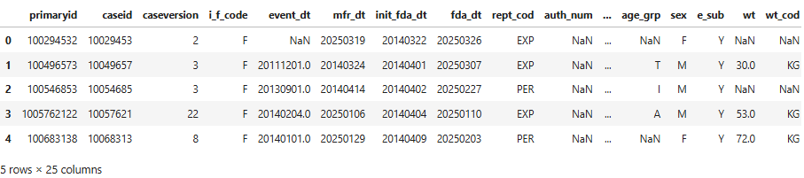
preview of few columns and rows
FDA's own guidance: for analysis, keep only the latest case version per case id (drop older versions), since that reflects the most current/accurate information for that case.
Next step was to find out the duplicate’s cases, as per case IDs there were total 148139 duplicate cases and 1469305 unique IDs and total number of rows were 1617444. So, we eliminated duplicate cases (148139). Only initial version for all cases was further used.
DRUG (Q1-Q4):
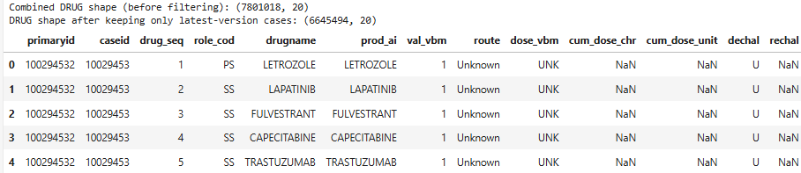
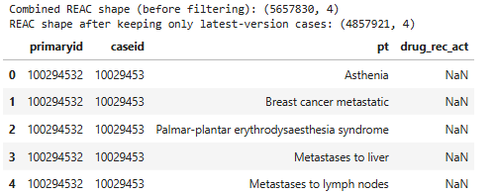
REAC (Q1-Q4): OUTC (Q1-Q4):
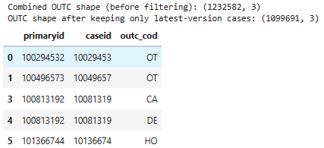
THER (Q1-Q4):
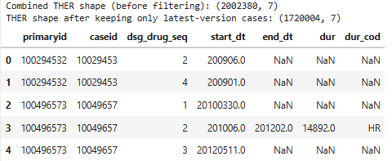
INDI (Q1-Q4): PSPR (Q1-Q4):
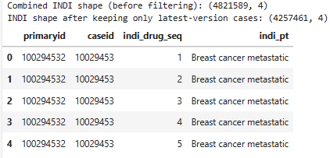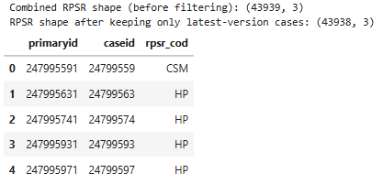
Aggregation Plan: Since our final dataset needs one row per case (to match DEMO), every multi-row table needs to be collapsed.
DRUG → split by role_cod (PS/SS/C/I/DN) and combine drug names within each group into one semicolon-separated string per case → columns: primary_suspect_drugs, secondary_suspect_drugs, concomitant_drugs, interacting_drugs, drug_not_administered. DN was removed as no drug was suspect in this case.
THER and INDI → these are per-drug, not per-case. attach them to DRUG using primaryid + drug_seq, then we aggregate DRUG in step 1, we carry forward therapy start/end and indication alongside each drug role group.
REAC → combine all pt (reaction terms) into one semicolon-separated string per case → reactions
OUTC → combine all outc_cod into one semicolon-separated string per case → outcomes (this is also what defines our target variable)
RPSR → combine all rpsr_cod into one semicolon-separated string per case → report_sources
Joining dataset:
THERAPY and INDICATION must join to DRUG on primaryid + drug_seq together — not primaryid alone. FDA's documentation (End Note 2) states that drug_seq is only unique within a single case, not across the entire dataset. Joining on primaryid alone silently mixes therapy dates and indications across different drugs within multi-drug cases.
Final dataset size:
After loading all 4 quarters and deduplicating to the latest version of each case, the final dataset contained 1,469,295 (after deduplication to latest case version) unique FAERS cases.
Target variable:
The target variable was derived directly from the OUTC (Outcome) table:
- Serious — the case has at least one row in the OUTC table (e.g., Death, Hospitalization, Life-Threatening, Disability, Congenital Anomaly, Required Intervention, or other Serious outcome).
- Non-Serious — no outcome was recorded for the case.
Class | Count | Percentage
Serious | 823,213 | 56.0%
Non-Serious | 646,092 | 44.0%
Table: Target class distribution, 2025 dataset (1,469,305 total cases). The class balance is mild, so no SMOTE

Understanding the dataset
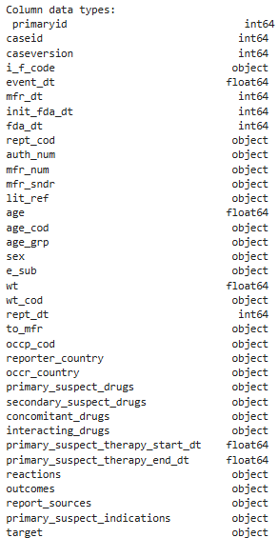
Data types Missing values
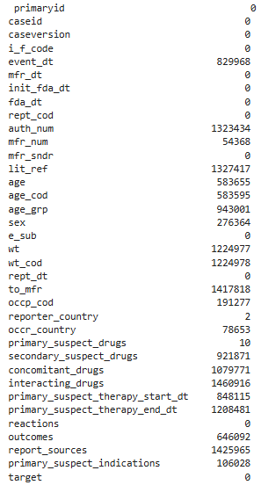
PREPROCESSING STEPS:
1. Type casting
Replaced all date columns to date time. event_dt, mfr_dt, init_fda_dt , fda_dt , rept_dt, primary_suspect_therapy_start_dt, primary_suspect_therapy_end_dt.
2. Handling missing value:
- Removed more than 80% missing values: auth_num, lit_ref, to_mfr, wt / wt_cod, report_sources, interacting_drugs- dropped.
- Age related variables: We checked missing values across age, age_cod, and age_grp:
age_grp present, age missing: 111,947 rows
age present, age_grp missing: 471,293 rows
Both present: 414,357 rows
Since neither field alone covered every case, we combined them — wherever exact age was available, we used it to derive the age group ourselves.
Mislabelled Dec was and replaced with YR.
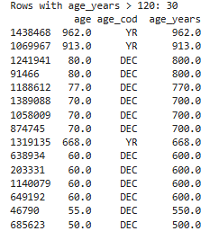
80 DEC, 77 DEC, 70 DEC, 60 DEC are almost certainly reporters entering the actual age in years but tagging it with the wrong unit code. A genuine "decade" entry should be a small number (e.g., 8 meaning 80 years), not 80. Since a decade count above ~12 is impossible (120 years).

Ages that were clearly impossible (like 962,913, 668 years) were removed. Once the combined age_group column was built, consists of adult, elderly, infant, neonate, elderly, child, missing (NAN). Checked for negative age, zero result found.
we dropped the original age and age_cod columns to avoid keeping redundant/duplicate information.

- Event related variables: event_dt was missing for 56% of cases, it was checked whether this missingness was random or concentrated in specific reporting categories. We compared the overall distribution of each category (rept_cod, i_f_code) against the missing-rate of event_dt within each category.
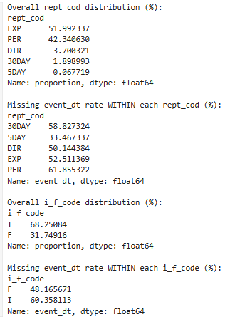
event_dt missingness is a genuine, widespread pattern in how FAERS reports are filled out this is not a bug specific to one part of our pipeline. Rather than guessing or imputing a fake date, we kept these values as missing and created a separate flag column, event_dt_reported (Reported / Not Reported), so the model could still use "whether an event date was provided" as a meaningful signal.
- As FAERS dates can come in as full (YYYYMMDD), year-month (YYYYMM), or year-only (YYYY) formats, per the data dictionary. We checked the date and all available dates are in 8-digit format. No partial dates were found.
- Handling other missing categorical columns: sex, occp_cod, occr_country, reporter_country
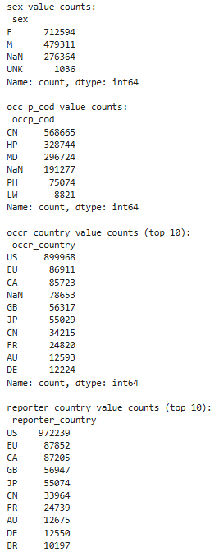
in sex: NaN and unk were merged into unknown and replaced. Same done for other columns as well. Everything replaced by Unknown.
- Mfr_num- dropped since administrative ID.
Inconsistency /abnormality check:
- report date (rept_dt) should not be before event date (event_dt): 17 rows were found where report date was before event date- 17 rows found and were replaced with ‘Not reported’.
- Checked implausible event_dt: three variables have future date and 19 has event dates before 1950’s. total 22 rows were replaced event_dt as ‘Not Reported’.
- Checked implausible mfr_dt: two dates found where mfr_dt is after rept_dt. Both replaced with NaT.
- therapy start/end dates for implausible values (before 1950 or in the future): total 16 rows identified under this category. It was replaced with NaT.
- removed extra spaces using strip.

Feature engineering:
Create duration-based features
Therapy duration (days) - how long the primary suspect drug was used
Reporting delay (days) - gap between event occurring and FDA receiving the report
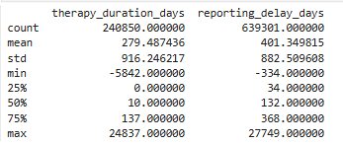
Therapy_duration_days: min = -5842 (end date before start date — impossible), max = 24,837 days (68 years of therapy — implausible) reporting_delay_days: min = -334 (FDA received report before the event even happened — impossible), max = 27,749 days (76 years delay — implausible)
Further investigation of negative or extreme values was performed: as result there were total 8970 negative therapy duration days and 10 negative reporting delay days. There were replaced with NaT.
Checked for extreme duration and it looks like many cases from 1950s the therapy start date is 01 January of that year. our parse_partial_date function: when FAERS only reports a year (not full date), we pad it to YYYY-01-01. So, these could be genuinely long-term medications (e.g., someone on thyroid medication or insulin since the 1950s, with the case only reported now) — not placeholder junk like the earlier 1900-01-01/2205-01-01 values.
Leaving it as it is — long-term chronic medication use is medically plausible, and it's a real (if imprecise) signal.
Extracted year, month, and weekday from event_dt for potential seasonal patterns: an unusual pattern on Wednesday was found and on further investigation it was due to pattern we already on as 1st of any month. This also says that most of the reporters didn’t information extract date of event, they mostly inform about the month and year it happened and added 01 as default date. This means event_weekday is not a reliable/meaningful feature. Hence dropped event_weekday entirely rather than feeding a misleading signal into the model.
Count based features selection: counted unique number of secondary suspect drug, concomitant drugs and reactions. removed if same drug appeared multiple times.

Statistical Understanding
Before log After log
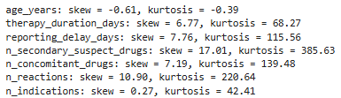
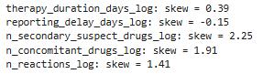

The two duration features are now well within acceptable range. The three count features improved a lot but are still technically above the 1 highly skewed. This was expected, since count data with a huge proportion of zeros (recall median was 0 for secondary/concomitant drugs) doesn't fully normalize even with log transform. This is a known limitation, not something to keep chasing further — tree-based models (which we're likely to use per our workflow) are not sensitive to skew/scale anyway, so this is more relevant for logistic models.

We'll keep both the raw and log versions for now — decide later during modelling which to actually use (tree models can use raw counts directly, so the log versions matter more if we try logistic regression as a baseline for comparison).

Visual understanding

Univariate analaysis of numeric columns (Histogram plus Boxplot)

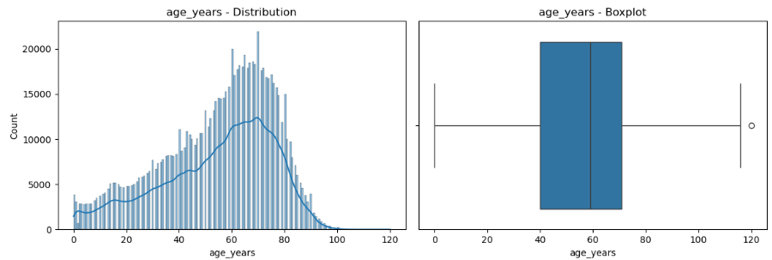

Summary of graph: age_years — nearly bell-shaped, mild left skew (matches skew -0.61), peak around 60-75. The one "outlier" flagged in the boxplot is just our capped max of 120 — expected.

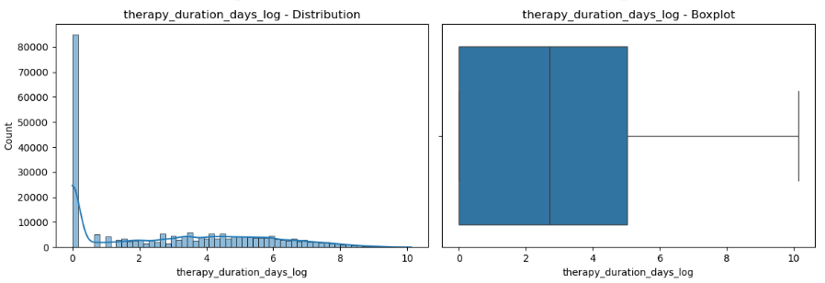

Summary of graph: therapy_duration_days_log — big spike at 0, that means many cases report the drug started and stopped the same day (or we have same start/end date), then a long, fairly flat tail.

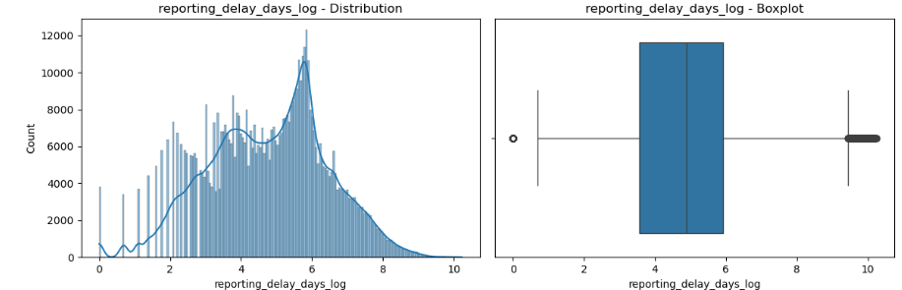

Summary of graph: reporting_delay_days_log. this one is multimodal (several visible peaks, not just one smooth hump). This is actually meaningful pattern rather than noise. FAERS has fixed reporting deadlines (15-day expedited vs 30-day periodic reports), so reporting delays may naturally cluster around those regulatory windows.

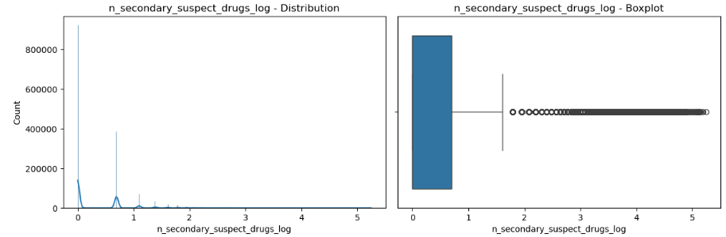

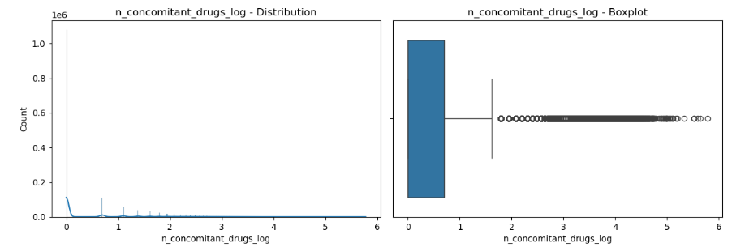

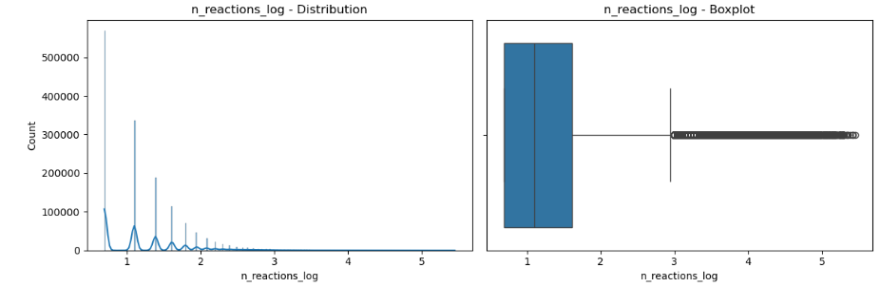

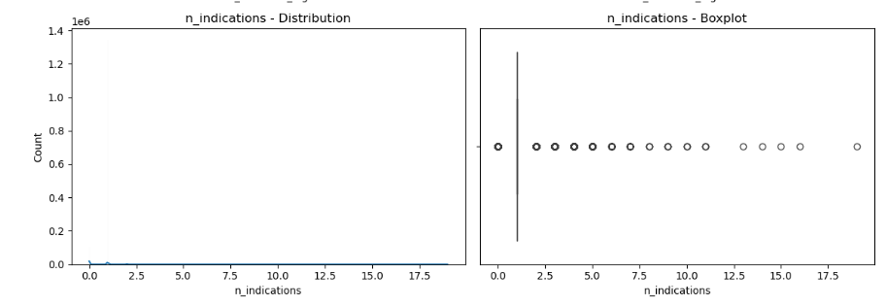

Summary of graph: n_secondary_suspect_drugs_log, n_concomitant_drugs_log, n_reactions_log, n_indications — all classic zero-inflated count distributions: a huge spike at 0/1, then a long tail of "outliers" in the boxplot. This is expected and normal for count data (most cases simply have zero secondary/concomitant drugs). These aren't errors, just the natural shape of the data. No action needed; tree-based models handle this kind of distribution fine.

Numeric features vs target variable (Boxplot):

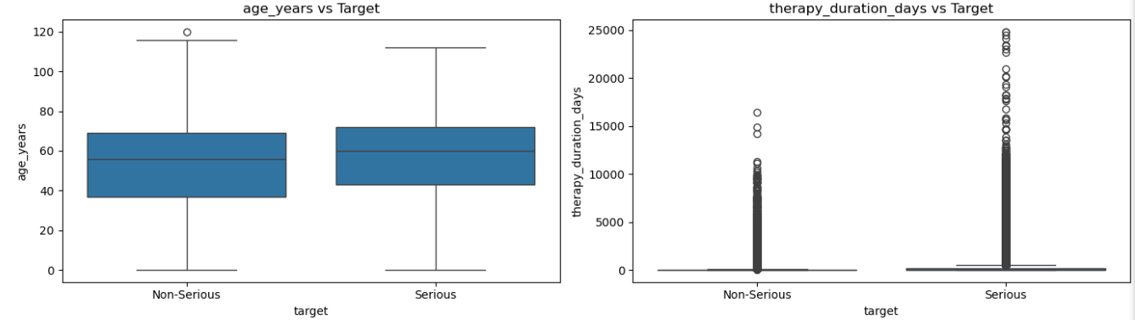
- age_years: non-serious case median around 55, box roughly spans 37 to 68 and serious cases median around 60, box roughly spans 45 to 72. nearly identical distributions between serious/non-serious.
- therapy_duration_days_log: while most cases (regardless of Serious/Non-Serious) have short therapy durations, the cases with very long therapy durations are noticeably more common among Serious cases — visible in the denser cluster of high-value dots on the Serious side.

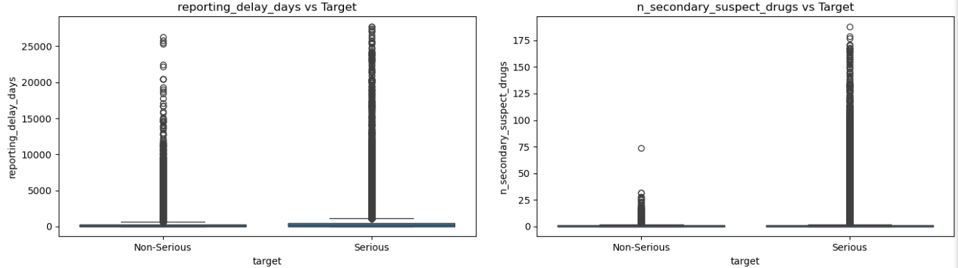
- reporting_delay_days_log: most cases irrespective of Serious or not gets reported to FDA fairly quickly relative to the event. But there's a slightly bigger tail of long-delay cases on the Serious side. It may mean longer delays often happen with complex, chronic conditions where it takes longer to recognize and report the connection between the drug and the adverse event — and those complex cases skew more Serious.
- n_secondary_suspect_drugs: Serious cases are more likely to have unusually high counts of secondary suspect drugs. This is a sign of more complex, multi-drug cases.

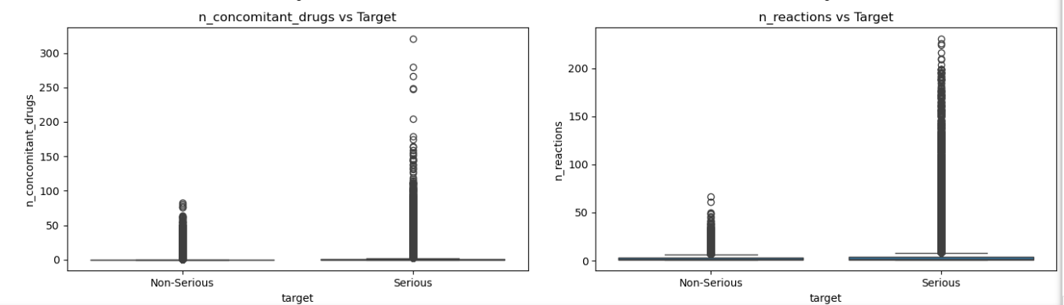
- n_concomitant_drugs: most non-serious cases have zero or very few concomitant drugs. the patient is mostly just on the one suspect drug. Serious cases show a much larger population of patients on many additional medications alongside the suspect drug some cases with 100, 150, even 300 other drugs listed.
- n_reactions: Serious cases are much more likely to have many distinct reactions reported for the same case. A case with 100+ different adverse reactions logged is describing a much more severe, complex medical event than a case with just 1-2 reactions — and that complexity strongly associates with the Serious classification.

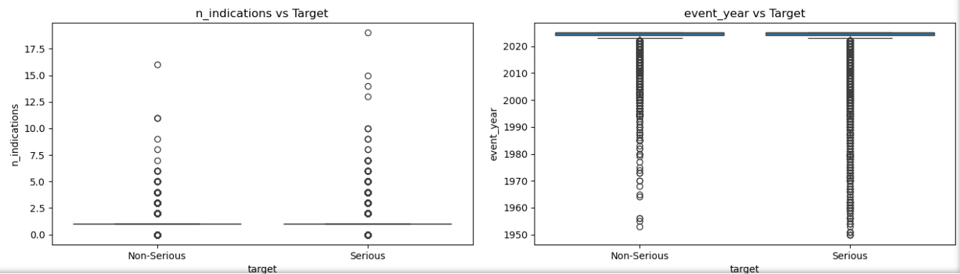
- n_indications, event_year: weak or negligible signals.

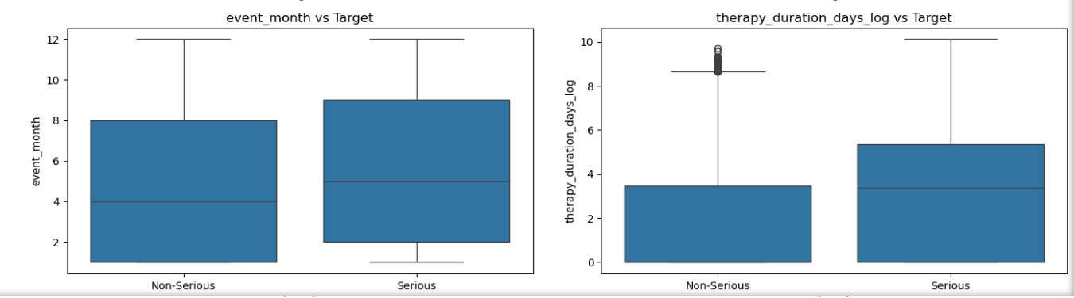
- event_month: Serious cases have a slightly higher median month and the box is shifted up a bit. Both groups' boxes overlap substantially though, so this isn't a strong pattern, just a mild one.
- therapy_duration_days_log: Non-Serious: median around 3.4, box spans 0 to 3.4, with a cluster of outliers above 8.5. Serious: median around 3.3 (nearly the same), but the box itself is taller and is between 0 to about 5.3. longer therapy duration is genuinely associated with Serious outcomes, visible now in the main body of the data, not just in rare extreme cases.

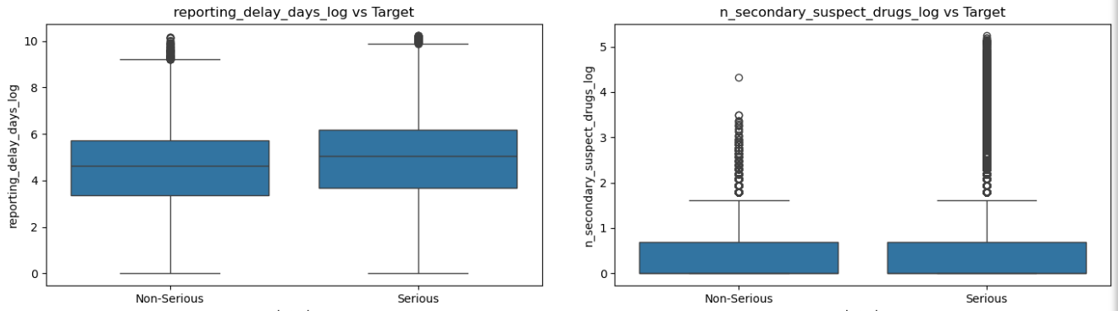
- reporting_delay_days_log: longer delays correlate with more complex cases that take longer to recognize and report, and complex cases skew Serious.
- n_secondary_suspect_drugs_log: Non-Serious: box flat near 0-0.6, with a tail of outliers going up to about 3.5. Serious: box also near 0-0.6 (very similar to non-Serious), but the outlier cloud is denser and reaches much higher up to 5.2+. Serious cases are more likely to have unusually complex, many-secondary-drug cases.

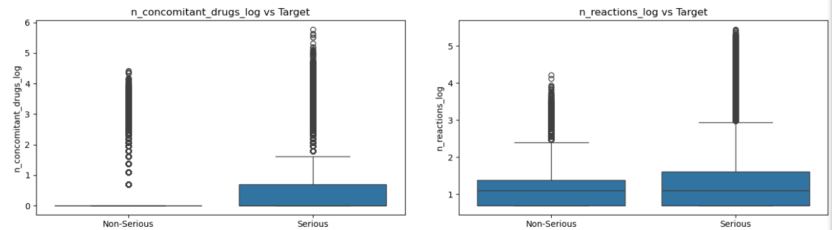
- n_concomitant_drugs_log: Non-Serious box is completely flat at 0 — the median AND most of the box sit right at zero, meaning most non-serious cases genuinely have zero concomitant drugs. Serious box now clearly rises up to about 0.6 — a real, visible box, not flat at zero
- n_reactions_log: Non-Serious median around 1.1, box spans roughly 0.7 to 1.4. Serious median around 1.1 (nearly identical!), box spans roughly 0.7 to 1.6 very slightly wider. on the raw chart, n_reactions looked like a strong signal (dense outlier cloud reaching 200+ for Serious). But on the log-transformed chart, the median/box barely differs at all between groups. This tells us the raw signal we saw earlier was mostly driven by a smaller number of extreme, very-high-reaction-count cases — once log-compressed, the "typical" case in both groups looks quite similar.
Categorical Features (Count Plot):
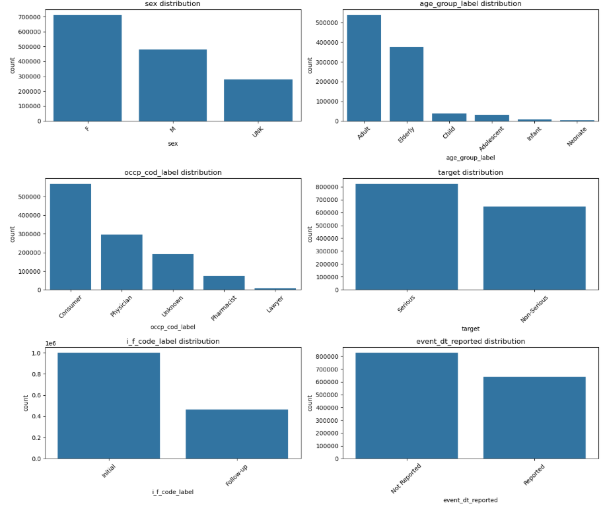

Summary
- sex: Female (nearby 712K) > Male (nearby 479K) > Unknown (nearby 277K).
- age_group: Adults dominate, then Elderly, it matches our earlier value_counts, sensible for adverse event reporting patterns.
- occp_cod: Consumers report the most (self-reported events), then Physicians, then Unknown, Pharmacists, Lawyers (rare) which is also reasonable.
- target: Serious (nearby 823K) vs non-Serious (nearby 646K) — matches our 56%/44% split.
- i_f_code: Initial reports dominate (nearby 1M) over Follow-up (nearby 470K) it shows most cases are one-time reports.
- event_dt_reported: Not Reported slightly more common than reported it matches our previous finding (56% missing).

Categorical Features Vs Target Variable (Count Plot):
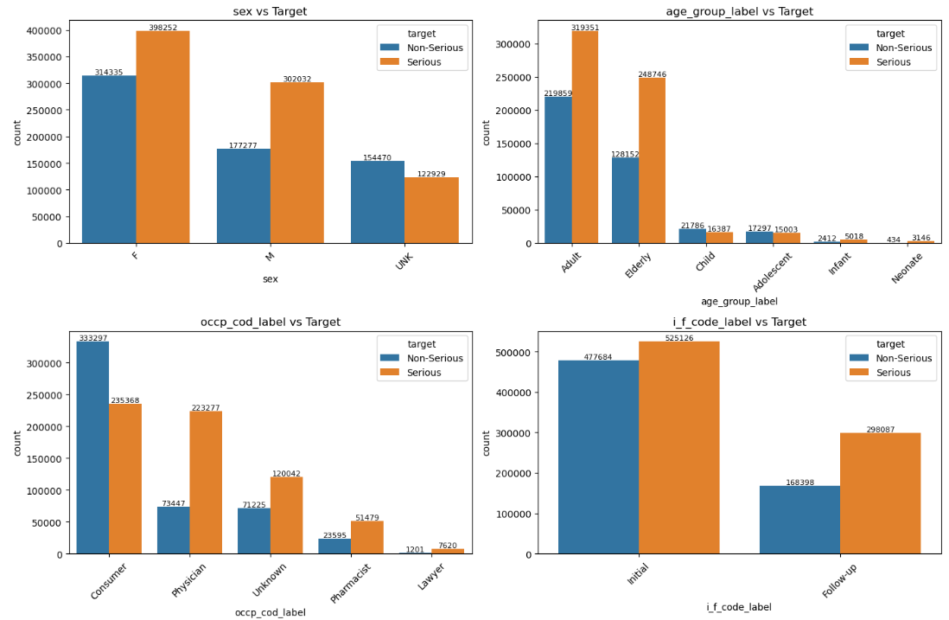
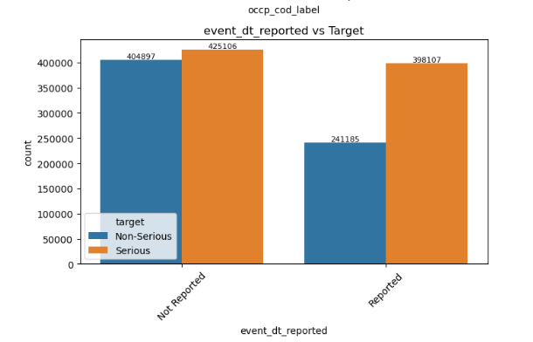

Summary:
- Sex: Female 56% Serious (398,252 vs 314,335), Male 63% Serious (302,032 vs 177,277), Unknown only 44% Serious (122,929 vs 154,470). It shows unknown-sex cases skew non-Serious
- Age group: Elderly is 66% Serious (248,746/376,898), Adult is 59% Serious (319,351/539,210) this confirms Elderly skews more Serious.
- Occupation: Physician-reported cases are 75% Serious (223,277/296,724) vs Consumer-reported only 41% Serious (235,368/568,665) this is the strongest categorical signal we've seen, and worth watching closely in feature importance later.
- Initial vs Follow-up: Follow-up is 64% Serious (298,087/466,485) vs Initial 52% Serious (525,126/1,002,810) this confirms follow-ups skewed towards serious.
- event_dt_reported: Roughly similar rates either way (nearby 51% vs nearby 62%, slight difference but not significant).

Multivariate Analysis of Numeric Features (Heatmap):

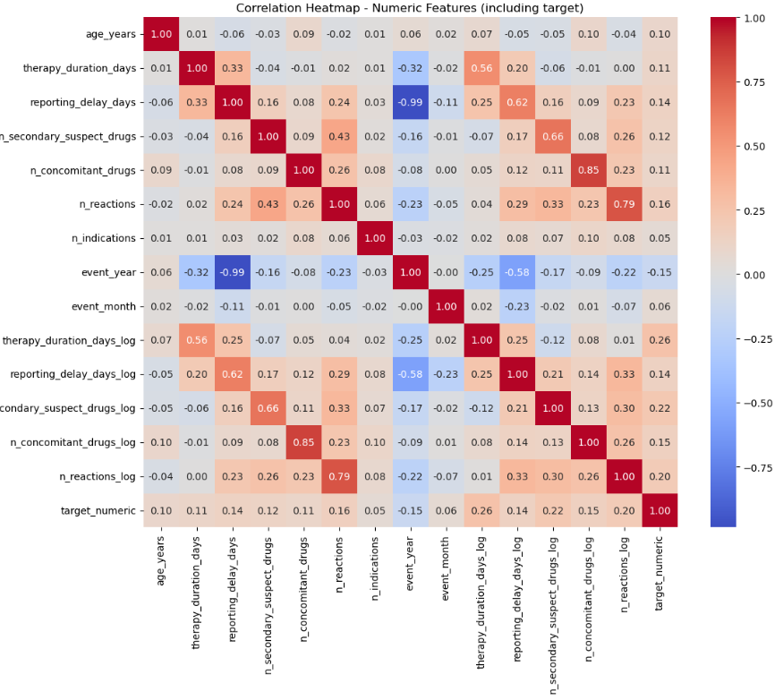

Summary:
Strongest positive correlations with target (Serious)- therapy_duration_days_log: 0.26 n_reactions_log: 0.20 n_secondary_suspect_drugs_log: 0.22 n_concomitant_drugs_log: 0.15 reporting_delay_days: 0.14 n_reactions: 0.16 age_years: 0.10.

Notably weak/near-zero- n_indications: 0.05 event_month: 0.06 event_year: -0.15 (weak negative — makes sense given the delay/year relationship)

Overall takeaway: No single numeric feature is strongly correlated with target on its own (all under 0.3). this is expected and normal for this kind of prediction problem, where the real signal is likely a combination of many features (plus the categorical ones like occp_cod we saw earlier, which had a much bigger visual gap).

worth noting: the log versions consistently correlate with target better than their raw counterparts (e.g., n_reactions_log 0.20 vs n_reactions 0.16) — good justification to prefer log versions if we end up using a linear/logistic model, though tree-based models can use either.

Feature Selection (before encoding)
- primaryid, caseid — unique per row to be dropped.
- outcomes — this is literally what target was derived from.To be dropped.
- Superseded raw dates (we've already extracted everything useful into event_year, event_month, therapy_duration_days(_log), reporting_delay_days(_log), event_dt_reported)
- mfr_dt, init_fda_dt, fda_dt, rept_dt, event_dt, primary_suspect_therapy_start_dt, primary_suspect_therapy_end_dt
- Superseded raw text lists (already converted into n_secondary_suspect_drugs, n_concomitant_drugs, n_reactions, n_indications) secondary_suspect_drugs, concomitant_drugs, reactions, primary_suspect_indications
Exception: primary_suspect_drugs — this is the actual drug name, potentially a strong signal (specific drugs carry real risk info), but too high-cardinality (6,721 unique values) for simple one-hot encoding. Options: drop for this baseline model, or keep and handle later (e.g., target-encoding, or just top-N most frequent drugs + "Other"). keeping it for now.
- Plot-only helper columns (created just for readable chart labels, not needed for modeling) age_group_label, occp_cod_label, i_f_code_label
- Administrative/low-value mfr_sndr (920 unique manufacturer names, high cardinality, low expected signal for a baseline model) caseversion (mostly administrative — reflects how many times a case was updated, not a clinical signal)
- Target duplication keeps target (or target_numeric) as our y variable — drop whichever one we don't end up using at modeling time. For now, keep both, decide at train-test-split stage.

Encoding
For the three high-cardinality columns (reporter_country, occr_country, primary_suspect_drugs), one-hot encoding all unique values would create thousands of different columns it will most likely to overfit. It needs to be resolved before one-hot encoding.
Upon checking the what % of data top-N categories cover.
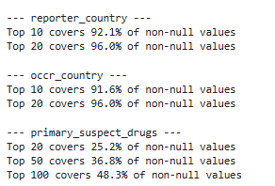
- reporter_country and occr_country: Top 20 gives 96% coverage — a great cutoff, minimal information loss.
- primary_suspect_drugs: Even top 100 only covers 48.3% — the drug name distribution has a very long tail (6,721 unique drugs), so no small N will capture "most" of the data. This confirms primary_suspect_drugs is fundamentally different from the country columns.
Top 20-50 + "Other": captures only the most common drugs individually, but over half the data becomes a single generic "Other" bucket — loses a lot of specific drug signal Top 100+: better coverage but still <50%, and now we're creating 100+ one-hot columns just for this one feature — heavy dimensionality for a "baseline" model.

- Created Bucket high-cardinality columns into top-N categories + "Other". In which top 20-50 countries plus one extra as other is being added to our variable.
- Ordinal encode age_group since it has a natural order (Neonate < Infant < Child < Adolescent < Adult < Elderly).
- One-hot encode nominal (unordered) categorical columns (i_f_code, rept_cod, sex, e_sub, occp_cod, event_dt_reported, reporter_country_bucketed, occr_country_bucketed, primary_suspect_drugs_bucketed)
- After encoding, the redundant variables were dropped.

Train-Test Split
- Split into train/test sets (80/20, standard for our dataset size.
- We use target_numeric (0/1) since sklearn models expect numeric targets.

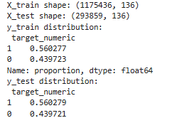

- Baseline model was trained with result: 72.5% accuracy and 0.81 ROC-AUC. While displaying important features below was observed.
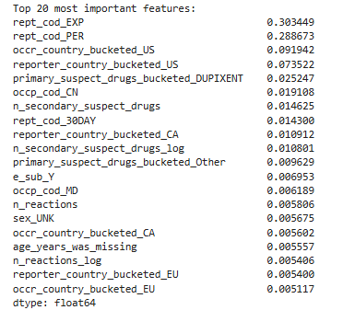

Summary: rept_cod_EXP + rept_cod_PER together account for nearby 60% of the model's total decision power.

As per the FDA data dictionary we saved earlier, rept_cod values mean: EXP = Expedited (15-Day) report PER = Periodic (Non-Expedited) report. Under FDA regulations, manufacturers are required to submit Expedited (15-day) reports specifically for serious, unexpected adverse events and Periodic reports are used for routine/non-serious submissions. This means rept_cod isn't really an independent predictive feature — it's essentially a regulatory classification that already encodes seriousness by definition, decided by humans/systems after they already determined the event was serious. Hence it rept columns were dropped and features were checked again.

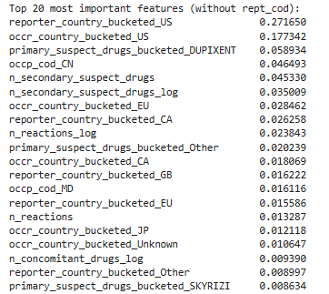

Summary: This is the same country-dominance pattern we found last time, now reappearing at the top once rept_cod was removed.
reporter_country_bucketed_US (25.4%) + occr_country_bucketed_US (19.3%) together account for nearby 45% of the model's importance. It is very similar to what we saw before (52% for reporter_country_us alone last time).
This matches our earlier documented finding: this is a real, explainable "selection bias" in how cases enter the FAERS database, not a clinical signal — the US reports at a different rate/severity threshold than other countries, so "is this a US report" tells the model much more about reporting patterns than about the actual drug/patient risk. Hence decision was taken to drop reporter_country/occr_country entirely and features were checked again.
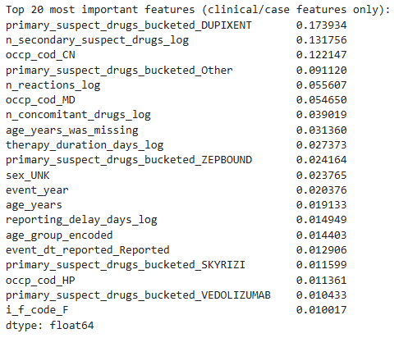

Summary:
primary_suspect_drugs_bucketed_DUPIXENT (17.4%) — dominant, but this makes sense: Dupixent is by far the single most common PS drug in our data (125,676 cases, nearby 8.5% of all cases) and is used for specific chronic conditions (asthma, eczema, etc.) that may have a distinct Serious/Non-Serious reporting pattern. Not an artifact — a genuine drug-specific signal, worth keeping.
n_secondary_suspect_drugs_log (13%)
occp_cod_CN (Consumer, 12.9%) —from our EDA Consumer-reported cases skew heavily non-Serious (41% Serious) vs Physician-reported (75% Serious). This is a real, explainable pattern (who reports, and how).
Primary_suspect_drug_bucketed_other (9%)

Train Baseline Model
With both artifacts removed (rept_cod and countries), the baseline Random Forest reached 78.5% accuracy and 0.866 ROC-AUC — a genuine improvement over the earlier 72.5%/0.81 result, now built on real clinical/case features (drug identity, drug/reaction counts, therapy duration, reporting delay, demographics). The confusion matrix was reasonably balanced.
Cross-Validation
Mean CV accuracy: 78.03%, standard deviation 0.01% — highly consistent across folds, indicating good model stability.
Hyperparameter Tuning (RandomizedSearchCV)
Tuning gave a consistent boost across every metric, not just one. max_depth=20 combined with min_samples_split=10/min_samples_leaf=2 (deeper trees, more conservative splitting) was the best trade-off found.

Feature importance, final tuned Random Forest
- Specific drugs (DUPIXENT, Other, ZEPBOUND) carry real risk signal.
- Reporter occupation (Consumer, Physician, Health Professional) reflects both genuine clinical severity and some reporting-pathway behavior.
- Drug/reaction counts reflect genuine polypharmacy/complexity.
- Age and its missingness flag both carry signal.
- Therapy duration and reporting delay contribute moderately.

Model comparison (at this stage of the analysis — before final tuning and LightGBM were added)
Model | Accuracy | Precision | Recall | F1 | ROC-AUC
Logistic Regression | 75.82% | 76.78% | 81.49% | 79.07% | 83.97%
Random Forest (tuned) | 79.25% | 80.93% | 82.37% | 81.64% | 87.45%
XGBoost (baseline) | 79.03% | 80.42% | 82.72% | 81.55% | 87.48%
XGBoost (tuned) | 79.02% | 80.28% | 82.91% | 81.58% | 87.44%

At this stage, Random Forest and XGBoost were essentially tied, both clearly ahead of Logistic Regression — this comparison gets revisited below once LightGBM is added and all three tree models are validated on genuinely unseen 2026 data, which is what ultimately decided the final model.

Checking model performance on unseen data
FAERS Q1 2026 was downloaded and processed with the same pipeline as the 2025 data, then used as a genuinely unseen test.

Model | 2025 Test Accuracy | 2025 Test ROC-AUC | 2026 Accuracy | 2026 ROC-AUC
Random Forest (tuned) | 79.25% | 87.45% | 74.93% | 84.99%
XGBoost (tuned) | 79.02% | 87.44% | 76.85% | 86.46%
For Random Forest specifically: recall rose sharply from 82.4% (test) to 90.1% (2026) — it catches even more truly Serious cases on new data — but precision dropped from 80.9% to 71.6%, meaning substantially more false positives (77,894 on 2026 vs. 31,953 on the test set). XGBoost, by contrast, held up more evenly across both metrics — an early signal of the stability advantage that later became the deciding factor.
Train a baseline LightGBM model
Baseline test-set performance: 77.63% accuracy, 78.90% precision, 82.01% recall, 80.43% F1, 86.03% ROC-AUC.

Hyperparameter tuning for LightGBM (RandomizedSearchCV)
Best parameters: subsample=0.8, num_leaves=50, n_estimators=200, max_depth=8, learning_rate=0.2 (best CV ROC-AUC: 87.94%).
Tuned test-set performance: 79.46% accuracy, 81.20% precision, 82.43% recall, 81.81% F1, 87.97% ROC-AUC — the best test-set score of all three tree models at this point.

Feature importance, tuned LightGBM
Note on units: LightGBM's default feature_importances_ counts how often a feature was used to split a tree, not a normalized 0–1 score like Random Forest's — valid for ranking, not directly comparable in scale.
Notably, no individual drug name appears in LightGBM's top 20 — a real difference from Random Forest, where Dupixent was the #1 feature. Instead, LightGBM leans on numeric continuous features: reporting delay, reaction count, age, concomitant drug count, secondary suspect drug count, and therapy duration all rank in its top 6.

Statistical significance check (test set)
The test set was resampled 1,000 times to check whether LightGBM's edge over Random Forest was real or noise. LightGBM won in nearly every resample, and the advantage was consistent and did not cross zero — confirming the test-set edge is statistically real, if modest. This check was test-set only, though — the question that actually decides which model to deploy is how each performs on genuinely unseen future data, addressed next.
Full three-model comparison: test set vs. genuinely out-of-time data (2026 Q1)
Model | Test ROC-AUC | 2026 (unseen future) ROC-AUC | Drop, test → future
Random Forest | 87.45% | 84.99% | 2.46 pts
LightGBM | 87.97% (best on test) | 86.29% | 1.68 pts
XGBoost | 87.44% | 86.46% (best on future data) | 0.98 pts (smallest drop)

Final model decision: XGBoost. LightGBM scores highest on the same-period test set, but XGBoost degrades the least between the test set and truly unseen 2026 data — the metric that actually matters for a model meant to be deployed on new, never-seen reports. XGBoost was selected as the final model on that basis, not on same-period test accuracy alone.

Late-stage refinement: removing reporting_delay_days
After the final model was chosen, a deployment-validity issue was identified: reporting_delay_days measures the time between the adverse event occurring and FDA receiving the report. By regulation (21 CFR 314.80), serious/unexpected cases must reach FDA within 15 days, while non-serious cases follow a slower periodic cycle — meaning this delay is partly a consequence of a seriousness decision already made, not an independent predictor of it.
More importantly, the model is intended to be used during triage, before a case has been submitted to FDA — at that point, "how long until this reaches FDA" isn't yet knowable. Keeping the feature would mean the deployed tool depends on information that doesn't exist yet at the moment it's meant to be used. The feature was therefore dropped entirely and XGBoost retrained on the reduced feature set (82 features, down from 84).

Metric | With delay feature | Without delay feature | Difference
Test Accuracy | 79.02% | 78.77% | −0.25 pts
Test ROC-AUC | 87.44% | 87.22% | −0.22 pts
2026 Accuracy | 76.85% | 75.69% | −1.16 pts
2026 ROC-AUC | 86.46% | 85.96% | −0.50 pts
A small, acceptable cost for a model that's now honest about what's actually knowable at the point it's used.
Decision threshold
Precision, recall, and F1 were compared at 0.3, 0.4, and 0.5 on the final XGBoost model:
Threshold | Precision | Recall | F1 | False alarms | Missed serious cases
0.3 | 70.4% | 94.7% | 80.7% | 65,668 | 8,761
0.4 | 75.6% | 89.5% | 82.0% (best) | 47,586 | 17,299
0.5 | 80.3% | 82.9% | 81.6% | 33,524 | 28,135
Threshold set to 0.4 — the best overall F1 balance, still catching ~89.5% of truly serious cases while generating meaningfully fewer false alarms than 0.3.
This is the true final, deployed model: XGBoost (tuned), trained without reporting_delay_days, decision threshold 0.4.
Conclusion
This project set out to correct and substantially strengthen an earlier, flawed attempt at predicting FAERS adverse event seriousness. Three models — Logistic Regression, Random Forest, and XGBoost, plus LightGBM as a fourth comparison — were trained, tuned, and rigorously evaluated on both a held-out 2025 test set and a genuinely unseen 2026 out-of-time validation set.

XGBoost was selected as the final model — not because it scored highest on the same-period test set (LightGBM narrowly did), but because it showed the smallest performance drop between the test set and truly unseen future data, making it the most reliable choice for real deployment. The model was further refined by removing reporting_delay_days, a feature found to depend on information not actually available at the moment the model is meant to be used — during triage, before a case has been submitted to FDA. The final model was deployed as a working application, with a decision threshold of 0.4, chosen to balance catching serious cases against false-alarm volume.

Clinical Context of Top Predictive Drugs
Toward Serious — Carboplatin (platinum chemo, ovarian cancer), Vedolizumab/Entyvio (biologic, UC/Crohn's), Skyrizi (biologic, psoriasis/Crohn's), Acetaminophen (analgesic).
Toward Non-Serious — Dupixent, Ozempic, Mounjaro, Zepbound, Rinvoq, Revlimid (top 6 by SHAP magnitude; Albuterol Sulfate, Genotropin, Bimzelx, Lantus Solostar, Nucala, Dapagliflozin, Tremfya carry smaller effects and are omitted here for brevity).
Note: several boxed-warning drugs above (Ozempic, Mounjaro, Zepbound, Revlimid, Rinvoq) still push toward non-Serious — a known-risk drug isn't the same as a case reported as serious; this reflects how these specific cases were coded, not the drugs' safety profiles.

Who can use it
- Drug companies receive thousands of adverse event reports; this model helps surface the likely-serious ones so safety teams review those first.
- Hospitals and clinicians could apply a similar approach to flag patients at higher risk after starting certain medications, for closer monitoring.
- Insurers could use risk prediction like this to anticipate which cases may lead to higher medical costs.
- Safety-software vendors could embed a model like this to automatically flag risky cases inside their own tools.

One important point to remember: this data comes from unconfirmed reports, so the model is suited to sorting and prioritizing — not to proving that a drug actually causes harm.

Limitations of this model:

- The underlying data is not confirmed. FAERS reports are suspected associations, not proven facts.
- Cannot establish cause and effect. The model finds patterns; it cannot show a drug actually causes an outcome.
- Missing data is significant. Fields like weight, age, and occupation had substantial missingness; median/default imputation is a workaround, not a full fix.
- The model partly reflects reporting behavior, not just medical risk — who reports (physician vs. consumer) affects the signal.
- Not usable for regulatory decisions. This model supports human review and prioritization; it does not replace formal seriousness determination.

References
FDA / FAERS — dataset, data documentation, and regulatory guidance (21 CFR 314.80)
DailyMed / NIH — official FDA drug labeling and boxed-warning information
MedDRA — standardized medical terminology and adverse-event coding
Drugs.com — drug-related reference information
Wikipedia — general background information
ChatGPT & Claude — coding assistance, troubleshooting, and concept clarification

